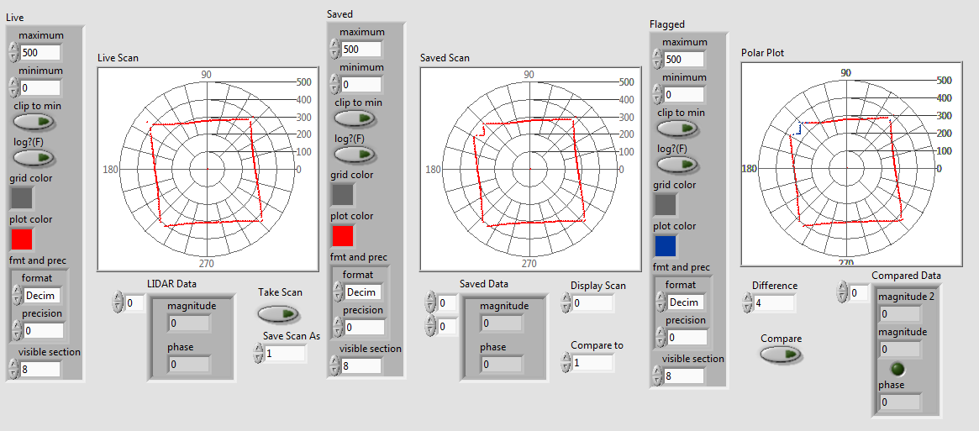

The above graphic shows two scans from the LIDAR taken at two different points in time. The scan on the right shows the change in between the first two scans marked in blue. This bodes well for the rest of my project, as it shows the lidar is accurate enough to detect changes in the environment.